**God’s Gang –** if your child has an allergy please tell the leader when he/she goes to God’s Gang

Thanks to Sheila and everyone who contributed to our excellent Summer Fete.

This afternoon we have been invited to the Mawlid celebrations in Fort Gardens by the Muslim Community in Gravesend.

**Wednesday 11th June Corpus Christi**

10am Holy Communion

5pm Evening Prayer

7.30pm Credo Group – exploring the Christian faith

**Thursday 19th June**

2.30pm Mustard Seed – tea cake, chat and good company

**Friday 20th June**

NATIONAL FLOWER ARRANGING DAY The Gravesend Flower Arrangers will be handing out small baskets and cupcakes outside Christ Church

**Friday 1.30pm** Christ Church Tots

**Saturday 21st June** Pilgrimage to St Albans

St Albans is easily accessible from Gravesend. Leaving Christ Church at 8am. Meet at the station at 8.30am (south side). We are proposing to leave on the 8.45am train – changing at St Pancras, hopefully returning by 7pm. The train fare will be about £23 (we should be able to get a group ticket , that’s the same price for those have railcards).

Please sign up if you would like to go.

**An evening on the Pleasance – Saturday 19th July**

£10 per adult £5 per child

Includes a glass of Pimms/Bucks Fizz

or orange juice on arrival

Miss Vintage will be performing

Arrive from 5.00 pm

Bring your own picnic

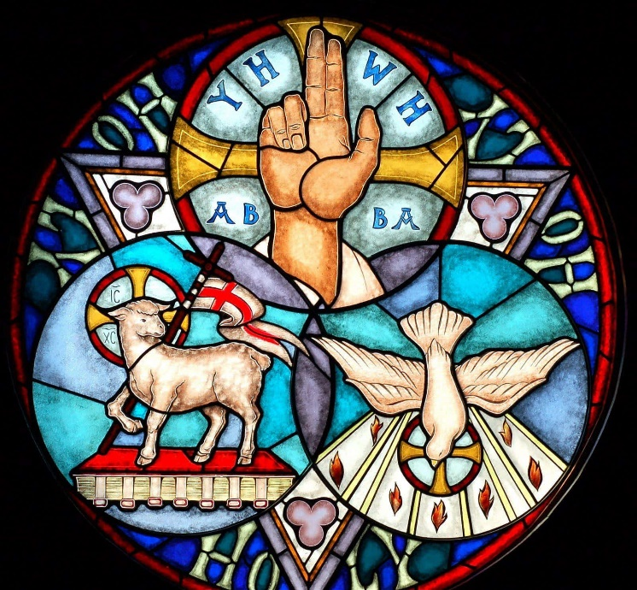

**CHRIST CHURCH**

**Milton next Gravesend**

*a faithfull welcome for all*

**www.christchurchgravesend.org.uk**

Vicar: The Revd Canon Dr Andrew Davey

[vicar@christchurchgravesend.com](mailto:vicar@christchurchgravesend.com)

01474 352643

**15th June 2025**

**Trinity Sunday**

8am Holy Communion

10am Parish Eucharist with God’s Gang (followed by refreshments)

**THIS MORNING’S HYMNS**

286 Holy Holy Holy

163Father Lord of all creation

SHEET Affirm anew

166 Father we adore you

284 Holy Holy

168 Father who in Jesus found us

296 How shall I sing

**Next Sunday 22nd June**

**1st Sunday after Trinity**

8am Holy Communion

10am Parish Eucharist followed by refreshments

12noon and 1pm Baptisms

**MORNING PRAYER is usually said on Monday, Tuesday, Thursday and Friday at 8.30amPlease check the weekly sheet. Join us on ZOOM. The Daily Prayer app can be downloaded on your smart phone.**

https://us02web.zoom.us/j/82117921556

**Please pray for**

Fathers

The people of Russia and Ukraine, Palestine and Israel, Iran, Los Angeles, Northern Ireland

Those who work in diplomacy and peace making

All affected by the plane crash in India

Those choosing the new Archbishop of Canterbury

The children in our church – God’s Gang, our preschool, Tots and First Steps

Please remember those who have died, especially Arthur Mowatt, Monica Hayden, Evelyn Wisdom, Peter Willis and Cynthia Whiteford, and those who mourn.

Remember in addition to the collection plate you can give to the Church using the card reader or online you will find our giving page using this QR code.