Thanks to those who helped with last night’s Beetle and Bingo extravaganza

God’s Gang – if your child has any allergies, please tell the leaders when he/she goes to God’s Gang.

Wednesday 21st January
10am Holy Communion
5pm Evening Prayer

Thursday 22nd January
10am Pilgrim Bible Study Group Genesis 32 Preparing to meet Esau – wrestling with….

Sunday 1st February
Presentation of Christ in the Temple (Candlemas)
6pm Choral Evensong

Saturday 14th February Table Top Sale
Enquiries for tables to Jenny Shoesmith or email tabletop@christchurchgravesend.com

We are planning a course for those children 8+ who wish to be admitted to communion at Easter. Please speak to Sheila Brown or the Vicar.

If you are interested in school admissions please speak to the welcomers, who will register your attendance. We cannot sign forms unless we have a record of your attendance.

A weekly children’s sheet is also available at the door. Please take one if you have someone you would like to pass it on to.
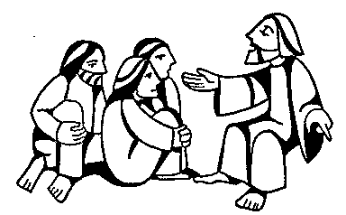


Remember in addition to the collection plate you can give to the Church using the card reader or online you will find our giving page using this QR code.

CHRIST CHURCH
Milton next Gravesend
a faithfull welcome for all

www.christchurchgravesend.org.uk
Vicar: The Revd Canon Dr Andrew Davey
vicar@christchurchgravesend.com
01474 352643

18th January
Second Sunday after Epiphany
8am Holy Communion
10am Parish Eucharist with God’s Gang followed by refreshments

THIS MORNING’S HYMNS
486 Christ is the king
775 Seek ye first
448 I come with joy
451 Just as I am
275 Holy holy holy one
332 Freed in Christ
652 Guide me O thou great redeemer

Next Sunday 25th January
3rd Sunday after Epiphany
The Conversion of St Paul
8am Holy Communion
10am Parish Eucharist followed by refreshments.

MORNING PRAYER Tuesday at 8.30am Join us in Church.
Morning prayer on Zoom will resume on Thursday 29th January.

Please pray for
Sarah Mullally, Archbishop elect
Those who work in diplomacy, aid and peace making
The people of Venezuela, Russia and Ukraine, Palestine and Israel, Iran
Those are homeless
Sanctuary and Daily Hub in Gravesend
Those who are the victims of hatred and violence
Emergency services
The churches of Gravesend as we begin the week of prayer for Christian unity
The children in our church – Semiquavers, Tots, First Steps, God’s Gang and our preschool
Please remember those who have died and those who mourn.

