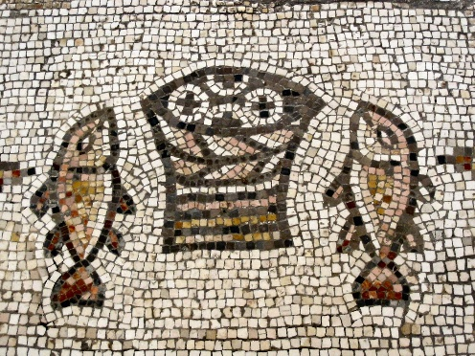

Wednesday 5th August
10am Holy Communion

TOMORROW – time to volunteer!
This week beginning 3rd August from 9am there are plenty of opportunities to help us keep the church and grounds the way we like them. Weeding, clearing, cleaning, washing and many more activities. Come along and help! Refreshments provided. Children need to be accompanied.

Please help families who are struggling this summer. Don’t forget our Foodbank collection – donations can be put in the bags in the porch. Tins of Custard, Tins of Hot meat/Cold Meat/Hot Dogs/Meat Pies, Crackers/Savoury Biscuits/Cereal Bars, Tins of Ravioli/Spaghetti Bolognaise, Small Bags of Rice (500g, 1kg, 2kg), Tins of Vegetables (Carrots, Peas, Green Beans, Broad Beans, Sweetcorn) Please make sure all food items are in date.

The funeral service for John Boucher will be on Thursday 20th August at 10.30am
The services for Marian Shearan will be on Friday 28th August. 1pm Thamesview Crematorium, 2pm at Christ Church.

Alex will be taking part in the 7.5km Ellenor Twilight Walk on Friday 18th September to raise funds in memory of Ted Barden. There are sponsor forms at the back of the church if you would like to sponsor him.

Remember in addition to the collection plate you can give to the Church online- you will find our giving page using this QR code.

If you are interested in school admissions please speak to the welcomers who will register your attendance.
We cannot sign forms unless we have a record of your attendance.

A weekly children’s sheet is also available at the door. Please take one if you have someone you would like to pass it on to.

CHRIST CHURCH
Milton-next-Gravesend
a faith-full welcome for all

www.christchurchgravesend.org.uk
Vicar: The Revd Canon Dr Andrew Davey
vicar@christchurchgravesend.com
01474 352643

2nd August 2026

NINTH SUNDAY AFTER TRINITY

8am Holy Communion
10am Parish Eucharist (followed by refreshments)

THIS MORNING’S HYMNS
593 At the name of Jesus
604 Brother sister
712 Lord Jesus Christ
433 Broken for me
462 Soul of my saviour
838 Jesus remember me
454 Love is his word
Next Sunday
9th August TENTH SUNDAY AFTER TRINITY
8am Holy Communion
10am Parish Eucharist (followed by refreshments)
2.30pm Memorial service for Prof Chrisopher Balogan-Lynch

MORNING PRAYER will resume on Monday 7th September at 8.30am.

Please pray for
All forced to flee their home because of war, violence, natural disaster and extreme weather
Iran, USA, Sudan, Lebanon, Ukraine and Russia, Palestine and Israel
Those who work in diplomacy and peace making
Those impacted by fires in Suffolk, Greece, France and Spain
Those waiting for exam results
Those who will find the school holidays difficult
All affected by the hot weather
The Foodbank, the Daytime Hub and those who use them
Please remember those who have died recently particularly, John Boucher, Marian Shearan, Christopher Balogan-Lynch, Daphne Lane and Brenda Roberts and those who mourn.

