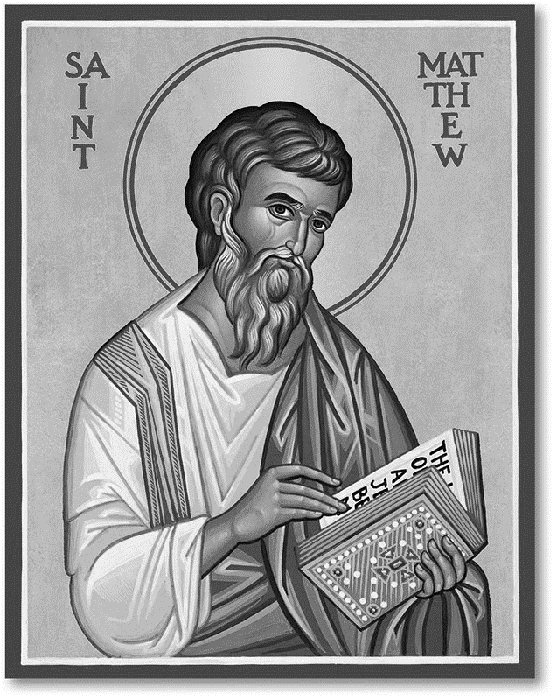

**God’s Gang - when your child goes out to God’s Gang please tell the leaders if she/he has any allergies.**

**Wednesday 24th September**

10am Holy Communion

5pm Evening Prayer

**Thursday 25th September 10 am Pilgrim Bible Study in the choir vestry** Genesis 23 *Burying Sarah – buying a stake in the promised land*

**Congratulations to Alex who has taken** part in the Ellenor Twilight Walk in memory of Ted Barden. There is still time to add to his sponsorship!

**Ann Russell’s funeral** will be at Christ Church on Tuesday 23rd September at 2pm followed by 3pm at Thamesview Crematorium

**Sunday 12th October** There will be a bring and share meal after our **Harvest** Eucharist please sign up at the back of church.

If you are interested in school admissions please speak to the welcomers, who will register your attendance.

We cannot sign forms unless we have a record of your attendance.

A weekly **children’s sheet** is also available at the door. Please take one if you have someone you would like to pass it on to.

**CHRIST CHURCH**

**Milton next Gravesend**

*a faithfull welcome for all*

**www.christchurchgravesend.org.uk**

Vicar: The Revd Canon Dr Andrew Davey

[vicar@christchurchgravesend.com](mailto:vicar@christchurchgravesend.com)

01474 352643

**21st September 2025**

**14th Sunday after Trinity**

8am Holy Communion

10am Parish Eucharist with God’s Gang followed by refreshments.

12noon and 1pm Holy Baptism

**THIS MORNING’S HYMNS**

149 Disposer supreme

590 Seek ye first

661 There’s s a spirit

18 All I once

930 In the Lord is my joy

77Blessed are the pure in heart

SHEET Christ is the one who calls

**Next Sunday 28th September**

**15th Sunday after Trinity**

8am Holy Communion

10am Parish Eucharist with baptism (followed by refreshments)

**MORNING PRAYER Tuesday, Thursday and Friday at 8.30am Join us in Church or on ZOOM. The Daily Prayer app can be downloaded on your smart phone.**

https://us02web.zoom.us/j/82117921556

**Please pray for**

The people of Russia and Ukraine, Palestine and Israel, Sudan

Those who are hungry and those who distribute food

All Christians in the Holy Lands

Those who work in diplomacy and peace making

Those forced to seek asylum because of need, war, and persecution.

The children baptised today

Jack and Emily who were married yesterday

Those choosing the new Archbishop of Canterbury

Those starting new courses or jobs

Please remember those who have died, particularly Ann Russell, and those who mourn.

Remember in addition to the collection plate you can give to the Church using the card reader or online you will find our giving page using this QR code.